 

|  |
| --- |
| **FPT- APTECH COMPUTER EDUCATION** |
| eProject Report |
| Vietnamese Tray |
|  |
| |  |  | | --- | --- | | **TẤU HÀI TEAM** | | | **Group Member** | -Phạm Văn Trung (Leader)  -Nguyễn Văn Quyết  -Trần Hùng Sơn | | **Batch** | <BatchName> | | **Center** | ACE-HANOI-2-FPT | | **Semester** | 4|4 | |

- Hanoi, 8/2021 –

**Contents**

**Problem Definition** 3

**1.** **Introduction** 3

**2.** **Iplementation Environment** 3

**User Stories** 4

**1.1** **Admin** 4

**1.2** **Customer** 5

**Usercase Diagram** 8

**Class Diagram** 11

**Sequence Diagram** 12

**Database** 17

**1.** **DB Relationship Diagram** 17

**2. SYSTEM Table List** 18

**UI\UX** 24

**1.ADMIN** 24

**- LOGIN** 24

**- DASHBOARD** 25

**- MANAGERs** 26

**2.CUSTOMER** 32

**- MAINPAGE** 32

**- REGISTER** 33

**- LOGIN** 34

**- PRODUCT VIEWs** 35

**- CART DETAIL** 36

**- CHECKOUT** 37

**- HISTORY** 38

**Summary** 39

# **Problem Definition**

### **Introduction**

*Nowadays, the devlopement of the science makes people life more and more convinient and well-living. As a result, the work of making new ways to communicate beetween a person and each other to do the trading is very necessary. Computers have very large storing capacity, it also does not make mistakes and working very fast. People also created the Internet to make it easier to connect everybody. Therefore, with the internet and computers we can create a system for seller and customers to make the trading easier and faster. We provide a faster and more effective solution for trading online.*

*Vietnam is a country rich in history and traditions, dating back thousands of years and instilled with a deep respect for the land, the sea and their ancestors. With a proundlyhistory and spririt of "Uong nuoc nho nguon", every holiday and festival are specials for the following generation to show the their grateful and pious for the ancestor. We making the “Vietnamese Tray” system to provide an easy and modern way for everyone to order the traditional foods and goods and prepare a completely tray in any special occasions.*

### **Iplementation Environment**

 

# **User Stories**

## **Admin**

-As an administrator i want to Login

-As an administrator i want to View User List

-As an administrator i want to View Category List

-As an administrator i want to Create a Category

-As an administrator i want to Edit a Category

-As an administrator i want to Delete a Category

-As an administrator i want to View Menu List

-As an administrator i want to Create a Menu

-As an administrator i want to Edit a Menu

-As an administrator i want to Delete a Menu

-As an administrator i want to View Menu Detail List

-As an administrator i want to Create a Menu Detail

-As an administrator i want to Edit a Menu Detail

-As an administrator i want to Delete a Menu Detail

-As an administrator i want to View Product List

-As an administrator i want to Create a Product

-As an administrator i want to Edit a Product

-As an administrator i want to Delete a Product

-As an administrator i want to Make a Finding in Database

-As an administrator i want to view Order Reports

-As an administrator i want to view Payment History

-As an Administator I want to View Reports in Bussiness

-As an Administator I want to View Statistical Charts

-As an Administator I want a Smart and Helpful Dashboard

-As an Administator I want an It easy to Use the system

## **Customer**

-As a customer i want to Register

-As a customer i want to Login

-As a customer i want to View Account Information

-As a customer i want to Edit Account Information

-As a customer i want a Smart and Easy to Use Theme

-As a customer i want to Find a Product

-As a customer i want to View Products

-As a customer i want to View Product's Detail

-As a customer i want to Find a Product

-As a customer i want it easy to Create an Order

-As a customer i want to Add a Product to Cart

-As a customer i want to View Cart Detail

-As a customer i want to Add a Product to Cart

-As a customer i want to Manage my Cart

-As a customer i want to Create my Order

-As a customer i want to View my Order Detail

-As a customer i want to Chose Payment Method

-As a customer i want to Manage my Order

-As a customer i want to Cancel my Order

-As a customer i want to Receive an Email show successfull order

-As a customer i want to make same Order in booking hisroty

-As a customer i want to use Service by Month/Year

-As a customer i want to Receive an Email that remind me an Event

-As a customer i want online Support

-As a customer i want to Check my Order History

-As a customer i want a Hotline for Contact

-As a customer i want to Receive an Email about Upcoming Events

-As a customer i want to Take a Fast Support on a Problem

-As a customer i want to Get Company Information

-As a customer i want to Send Feedbacks

-As a customer i want to view Traditional events

-As a customer i want to view Support, Guiding information

# **Usercase Diagram**

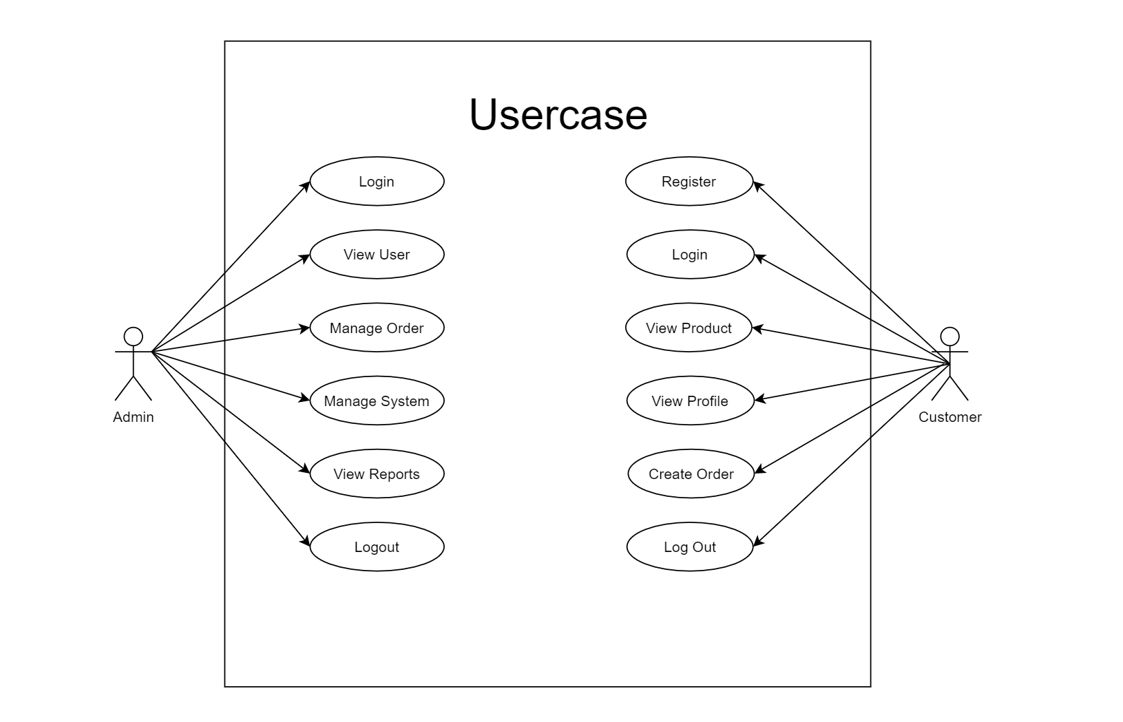

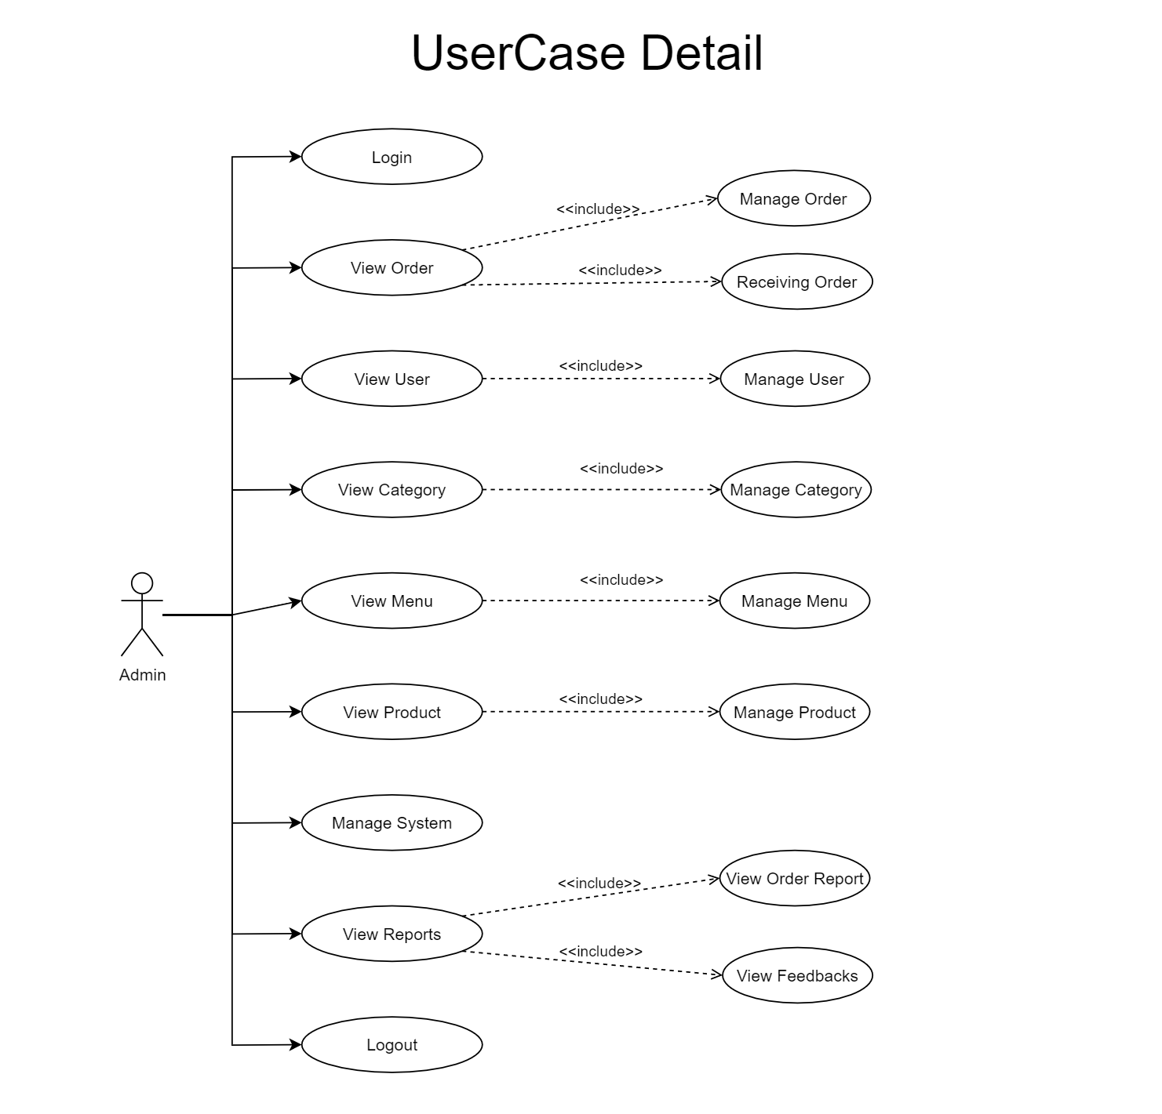

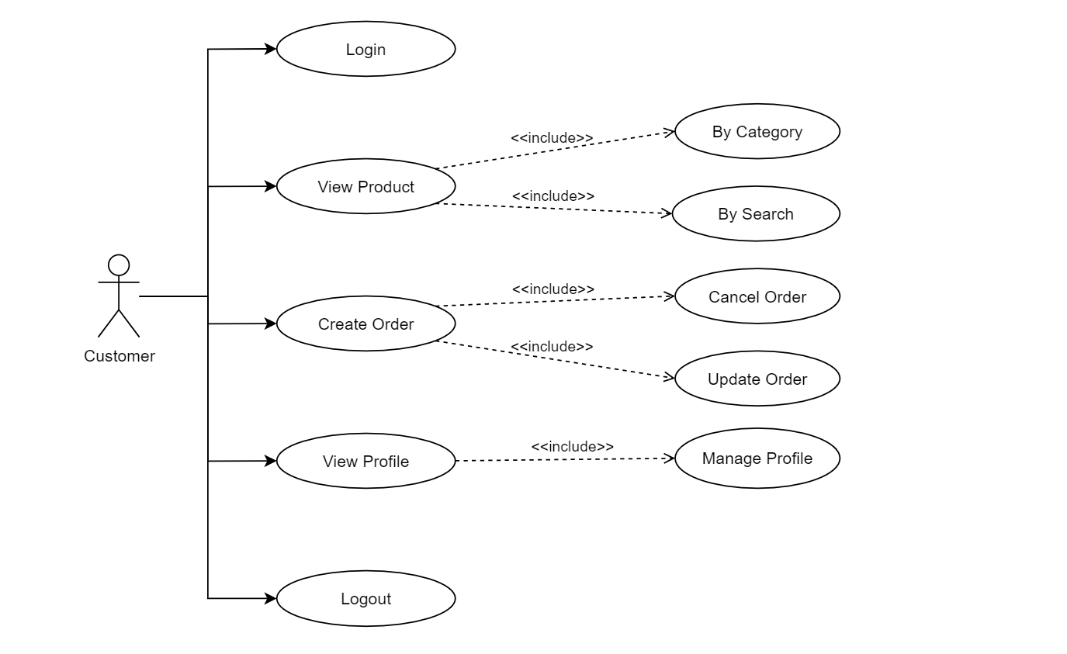

# **Class Diagram**

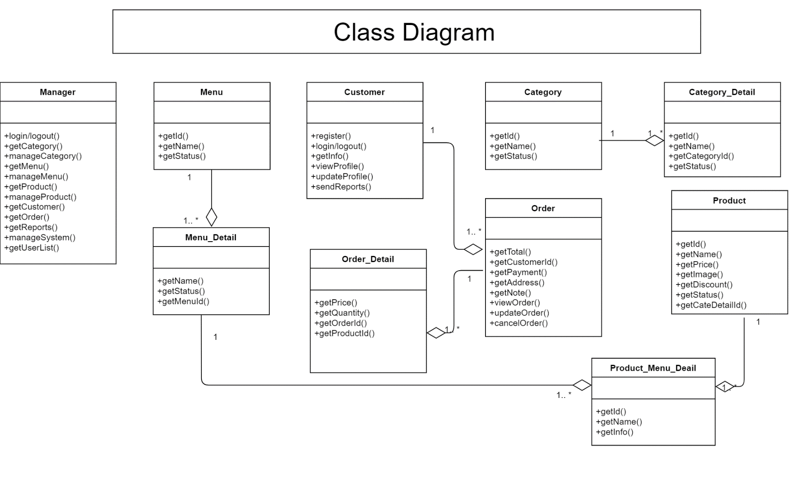

# **Sequence Diagram**

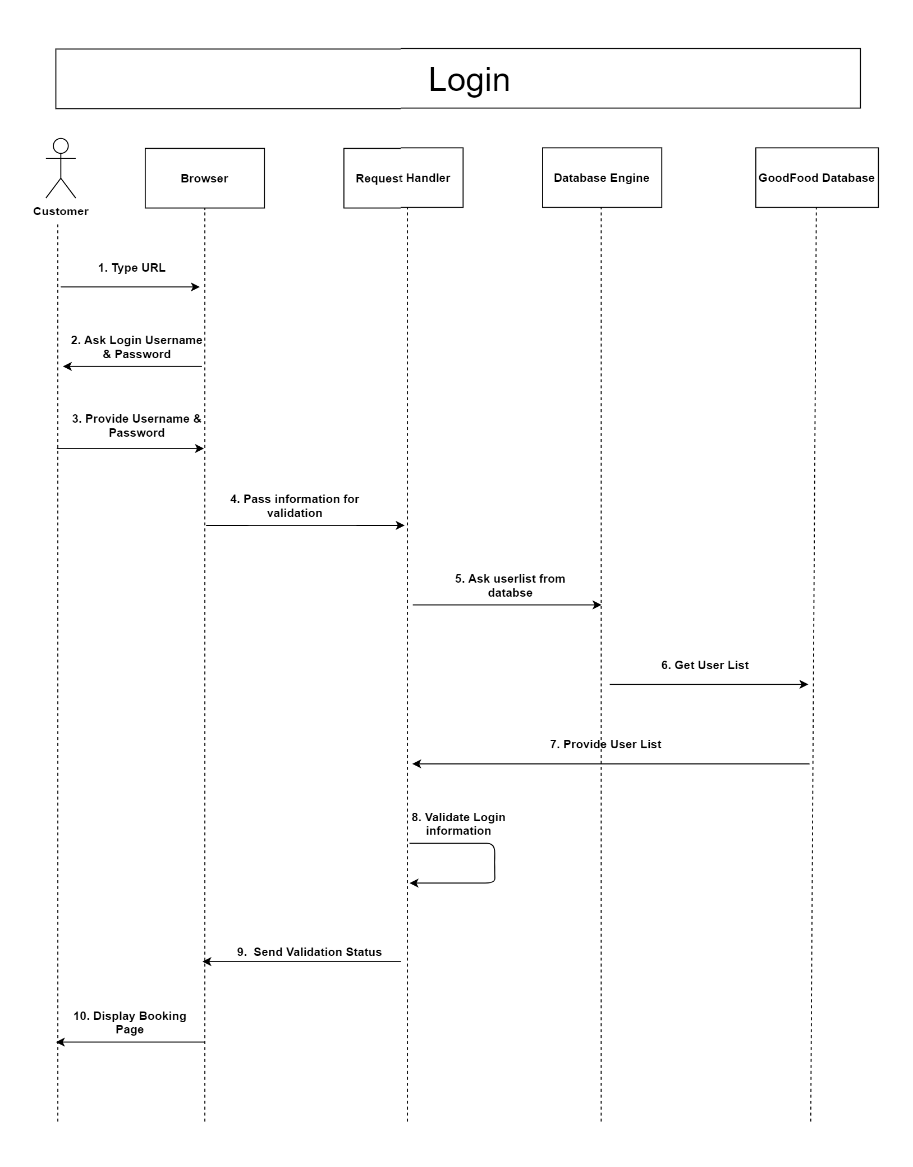

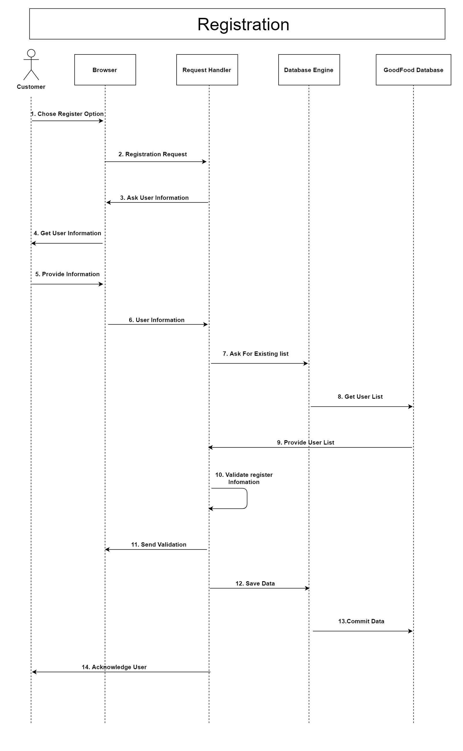

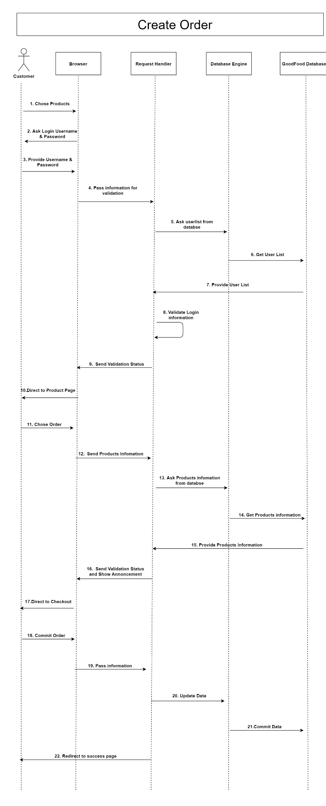

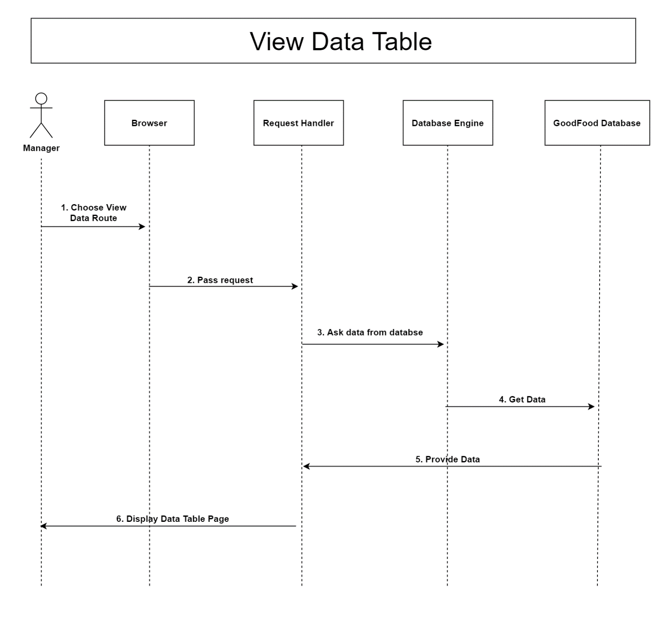

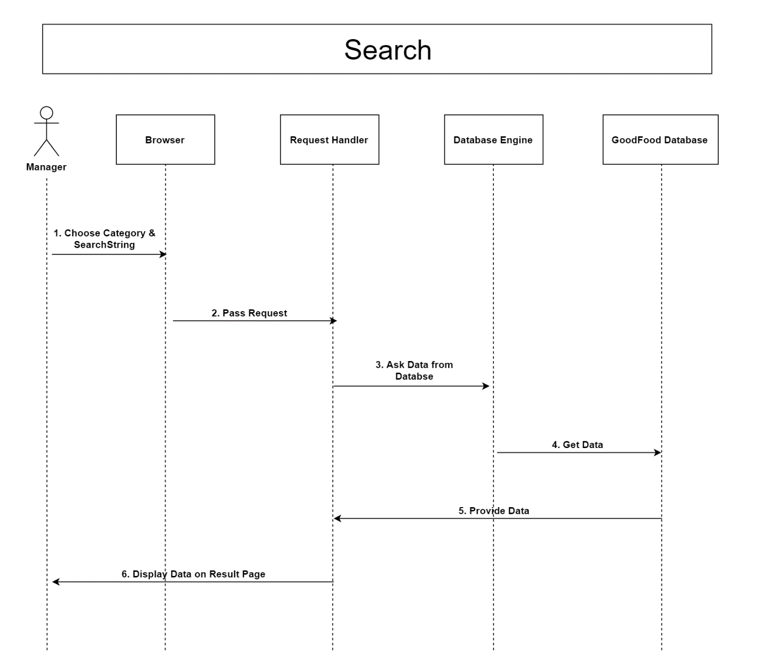

# **Database**

## **DB Relationship Diagram**

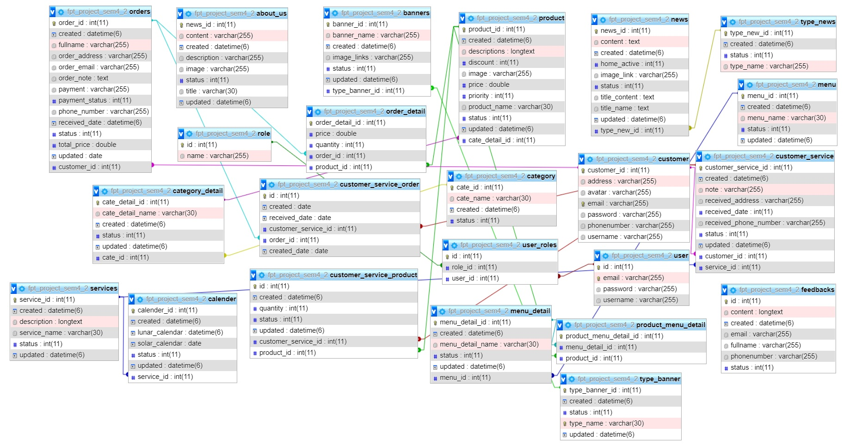



## **2. SYSTEM Table List**

**-Role**

|  |  |  |  |
| --- | --- | --- | --- |
| **Column Name** | **Data Type** | **Constraint** | **Description** |
| ID | Int(11) | PK | Primary key of the table |
| Name | Varchar(255) | Not null | Role name, to identify a role |

**-User**

|  |  |  |  |
| --- | --- | --- | --- |
| **Column Name** | **Data Type** | **Constraint** | **Description** |
| ID | int(11) | PK | Primary key of the table |
| Email | varchar(255) | Not null | Role name, to identify a role |
| Password | varchar(255) | Not null |  |
| Username | varchar(30) | Not null | User name, to identify a account |

**-User_Roles**

|  |  |  |  |
| --- | --- | --- | --- |
| **Column Name** | **Data Type** | **Constraint** | **Description** |
| ID | int(11) | PK | Primary key of the table |
| Role_ID | int(11) | FK, Not null | Foreign key of table |
| User_ID | int(11) | FK, Not null | Foreign key of table |

**-Customer**

|  |  |  |  |
| --- | --- | --- | --- |
| **Column Name** | **Data Type** | **Constraint** | **Description** |
| Customer_ID | int(11) | PK | Primary key of the table |
| Address | varchar(255) |  | Customer’s Address |
| Avatar | varchar(255) |  | Avatar imgae file link |
| Email | varchar(255) | Not null |  |
| Password | varchar(255) | Not null |  |
| PhoneNumber | varchar(255) |  |  |
| Username | varchar(255) | Not null | Username, to identify a customer account |

**-Category**

|  |  |  |  |
| --- | --- | --- | --- |
| **Column Name** | **Data Type** | **Constraint** | **Description** |
| Cate_ID | int(11) | PK | Primary key of the table |
| Cate_Name | varchar(30) | Not null | Name of the Category |
| Created | datetime(6) |  |  |
| Status | int(11) |  |  |

**-Category_Detail**

|  |  |  |  |
| --- | --- | --- | --- |
| **Column Name** | **Data Type** | **Constraint** | **Description** |
| Cate_Detail_ID | int(11) | PK | Primary key of the table |
| Cate_Detail_Name | varchar(30) | Not null | Name of the Category Detail |
| Created | datetime(6) |  |  |
| Status | int(11) |  |  |
| Updated | datetime(6) |  |  |
| Cate_ID | int(11) | FK, Not null | Foreign key of table |

**-Menu**

|  |  |  |  |
| --- | --- | --- | --- |
| **Column Name** | **Data Type** | **Constraint** | **Description** |
| Menu_ID | int(11) | PK | Primary key of the table |
| Created | datetime(6) |  |  |
| Menu_Name | varchar(30) | Not null |  |
| Status | int(11) |  |  |
| Updated | datetime(6) |  |  |

**-Menu_Detail**

|  |  |  |  |
| --- | --- | --- | --- |
| **Column Name** | **Data Type** | **Constraint** | **Description** |
| Menu_Detail_ID | int(11) | PK | Primary key of the table |
| Created | datetime(6) |  |  |
| Menu_Detail_Name | varchar(30) | Not null |  |
| Status | int(11) |  |  |
| Updated | datetime(6) |  |  |
| Menu_ID | int(11) | FK | Foreign key of table |

**-Product_Menu_Detail**

|  |  |  |  |
| --- | --- | --- | --- |
| **Column Name** | **Data Type** | **Constraint** | **Description** |
| Product_Menu_Detail_ID | int(11) | PK | Primary key of the table |
| Menu_Detail_ID | int(11) | FK, Not null | Foreign key of table |
| Product_ID | int(11) | FK, Not null | Foreign key of table |

**-Orders**

|  |  |  |  |
| --- | --- | --- | --- |
| **Column Name** | **Data Type** | **Constraint** | **Description** |
| Order_ID | int(11) | PK | Primary key of the table |
| FullName | varchar(255) | Not null |  |
| Order_Address | varchar(255) | Not null |  |
| Order_Email | varchar(255) | Not null | Email of the customer |
| Order_Note | varchar(255) |  | Note for the order |
| Payment | varchar(255) | Not null | Payment Method |
| Status | int(11) |  |  |
| Total_Price | double |  |  |
| Customer_ID | int(11) | FK, Not null | Foreign key of table |
| Created | datetime(6) |  |  |
| Updated | datetime(6) |  |  |

**-Orders_Detail**

|  |  |  |  |
| --- | --- | --- | --- |
| **Column Name** | **Data Type** | **Constraint** | **Description** |
| Order_Detail_ID | int(11) | PK | Primary key of the table |
| Price | double |  |  |
| Quantity | int(11) |  |  |
| Order_ID | int(11) | FK, Not null |  |
| Product_ID | int(11) | FK, Not null |  |

**-Product**

|  |  |  |  |
| --- | --- | --- | --- |
| **Column Name** | **Data Type** | **Constraint** | **Description** |
| Product_ID | int(11) | PK | Primary key of the table |
| Descriptions | varchar(255) | Not null |  |
| Discount | int(11) |  |  |
| Image | varchar(255) |  |  |
| Price | double |  |  |
| Priority | int(11) |  |  |
| Product_Name | varchar(30) | Not null |  |
| Status | int(11) |  |  |
| Cate_ID_Detail | int(11) | FK, Not null | Foreign key of table |
| Created | datetime(6) |  |  |
| Updated | datetime(6) |  |  |

**-Feedbacks**

|  |  |  |  |
| --- | --- | --- | --- |
| **Column Name** | **Data Type** | **Constraint** | **Description** |
| ID | int(11) | PK | Primary key of the table |
| Content | varchar(255) | Not null | Feedback of customer |
| Created | datetime(6) |  |  |
| Email | varchar(255) | Not null |  |
| FullName | varchar(255) | Not null |  |
| PhoneNumber | varchar(255) |  |  |
| Status | int(11) |  |  |

# **UI\UX**

## **1.ADMIN**

### **- LOGIN**

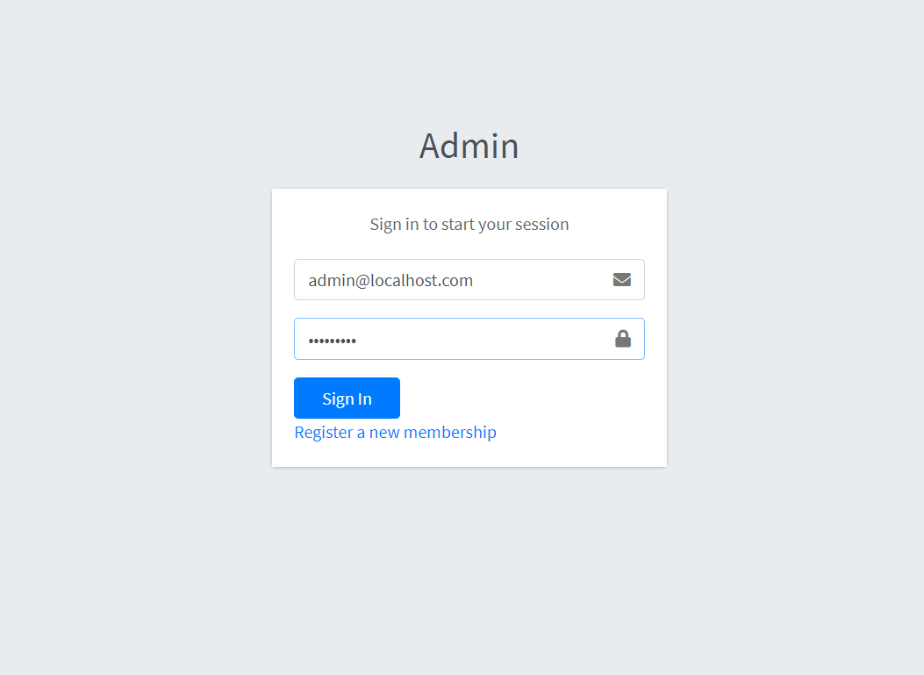

### **- DASHBOARD**

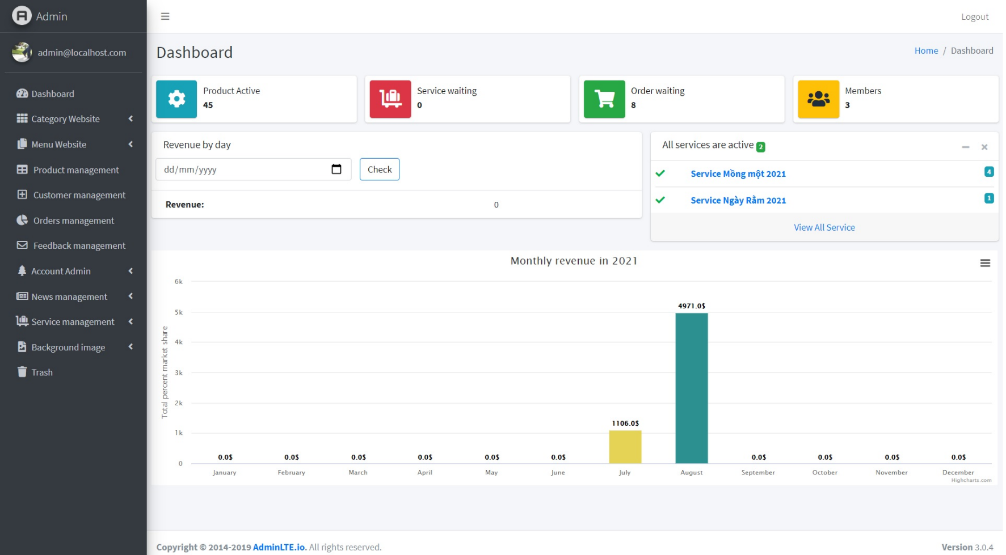

### **- MANAGERs**

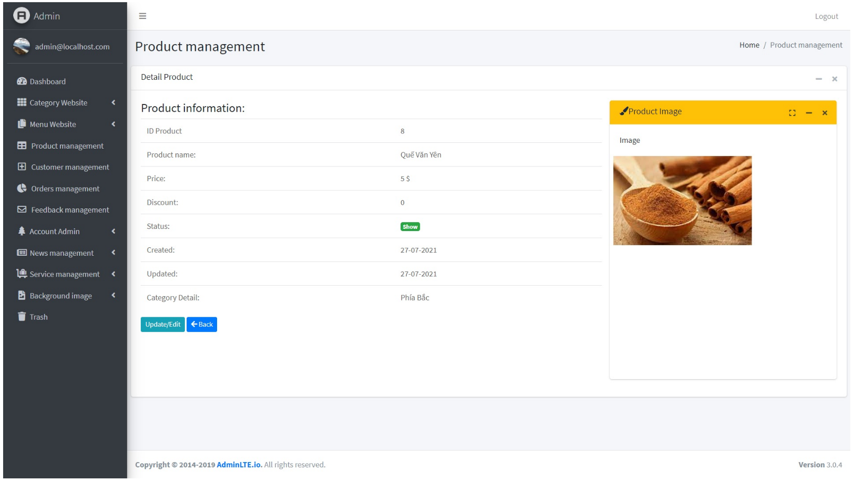

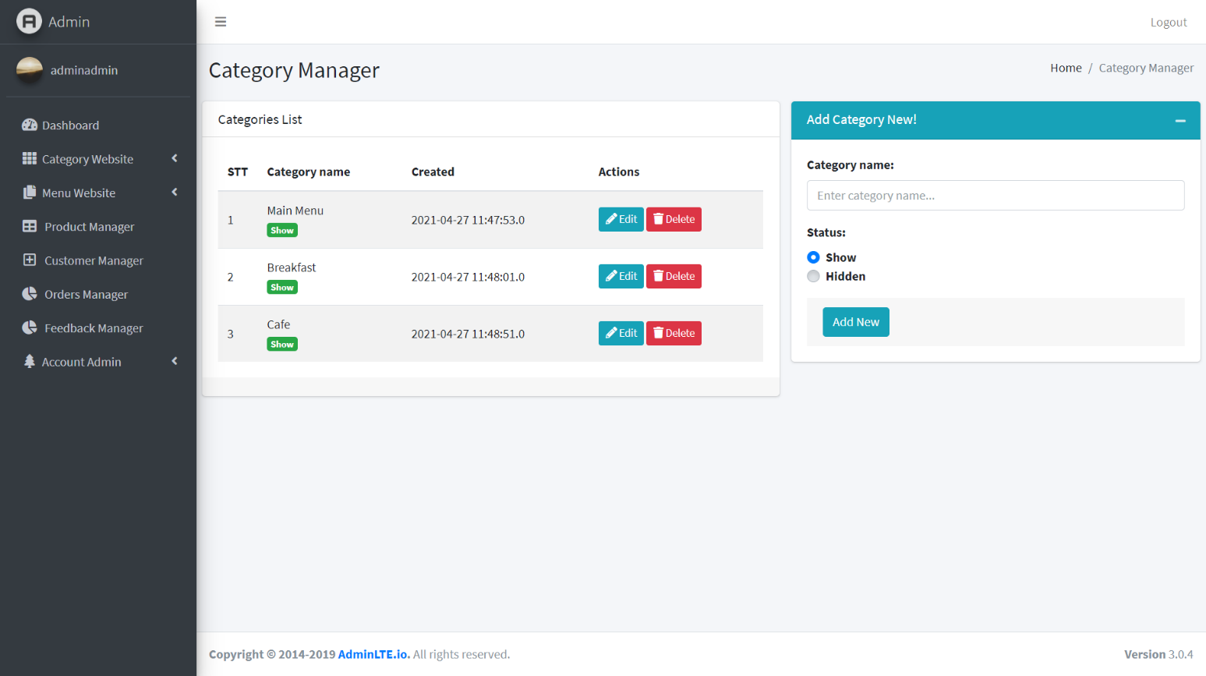

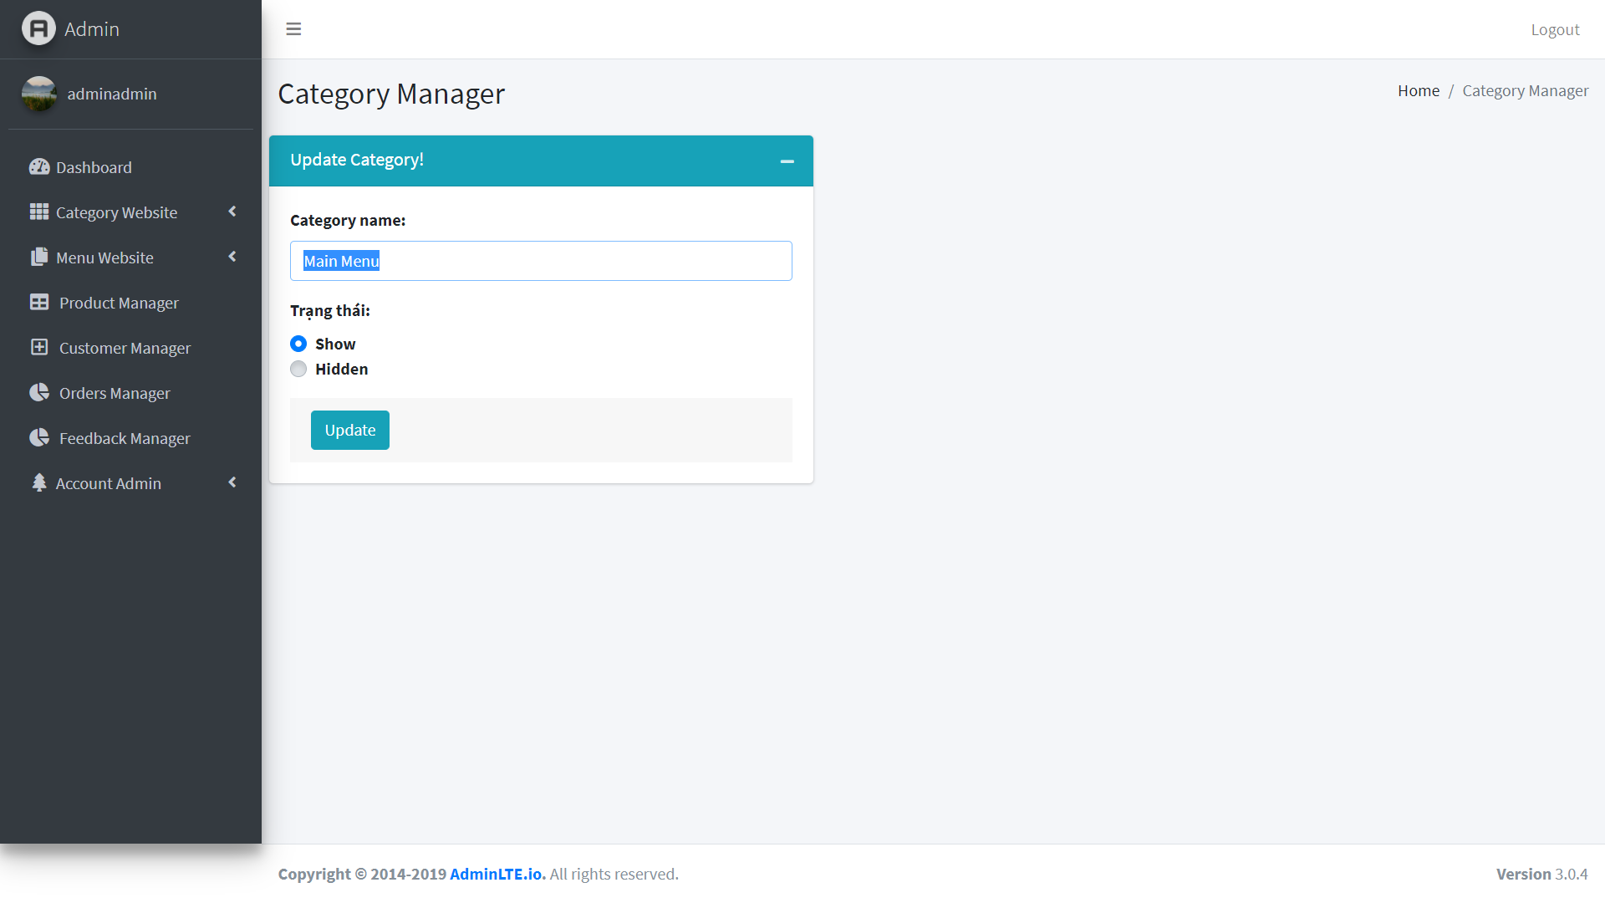

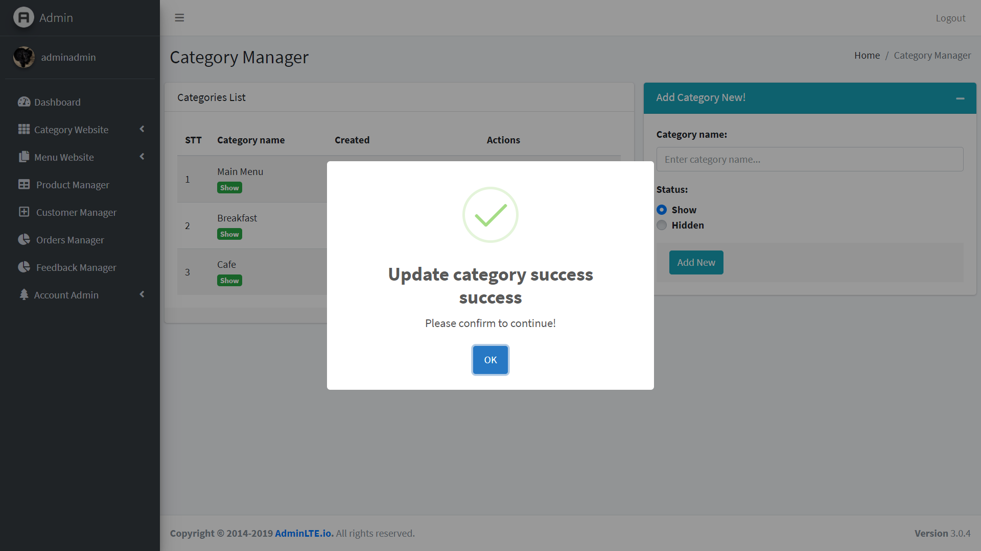

+Service Manager

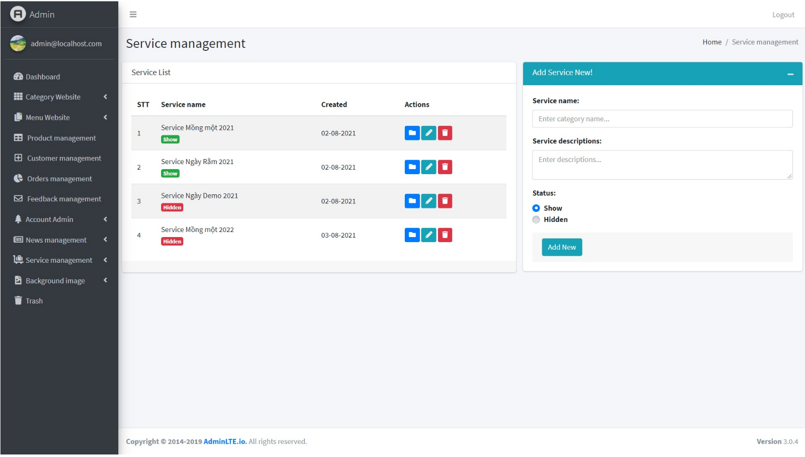

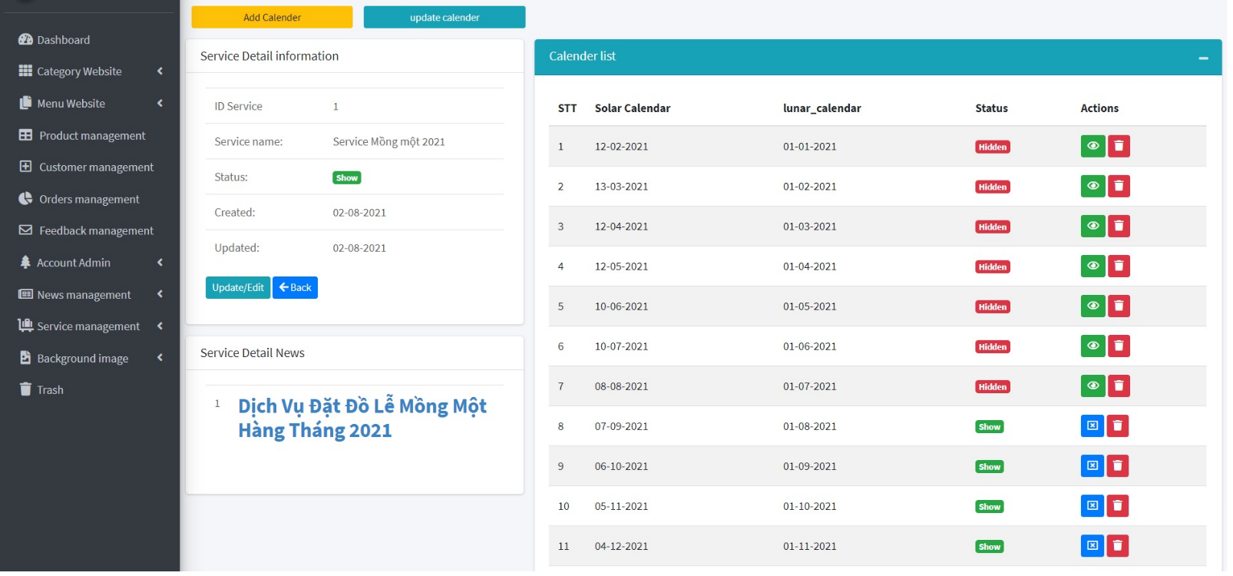

+Trash Manager

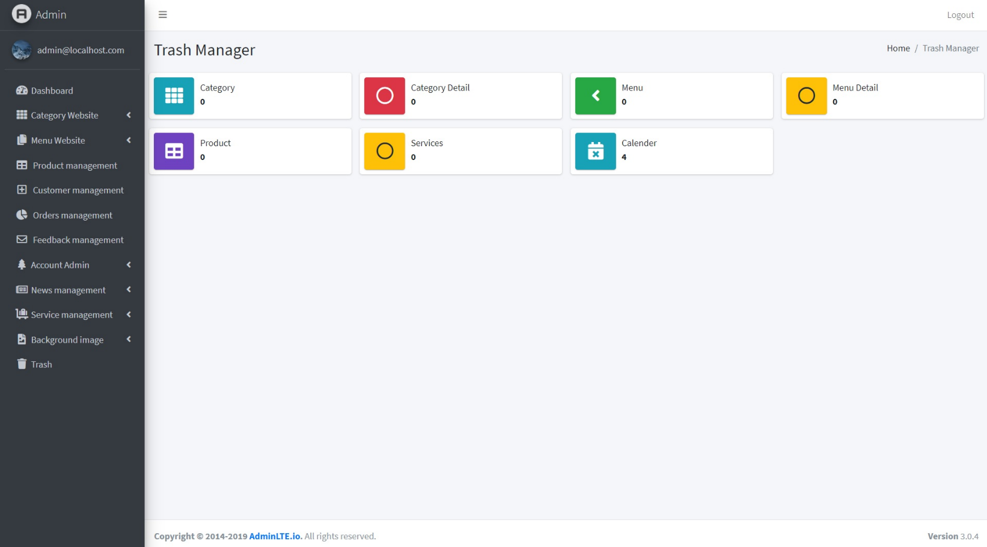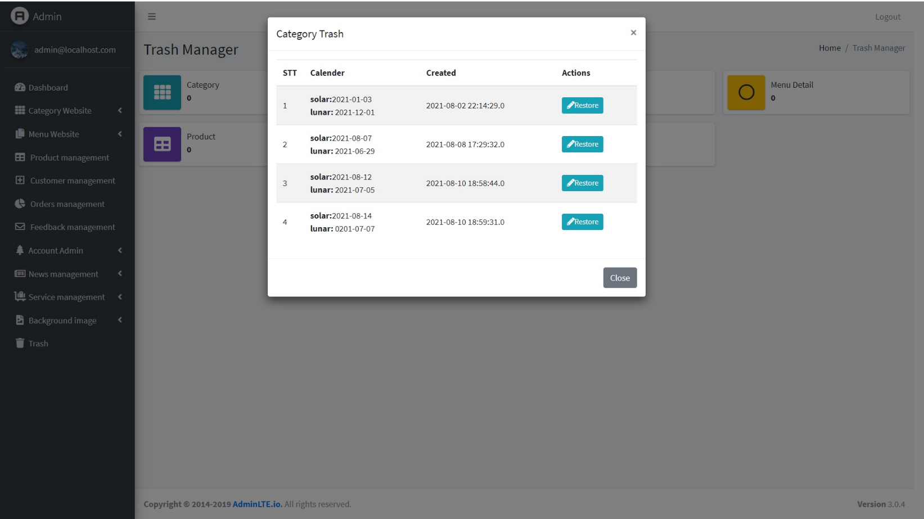



## **2.CUSTOMER**

### **- MAINPAGE**

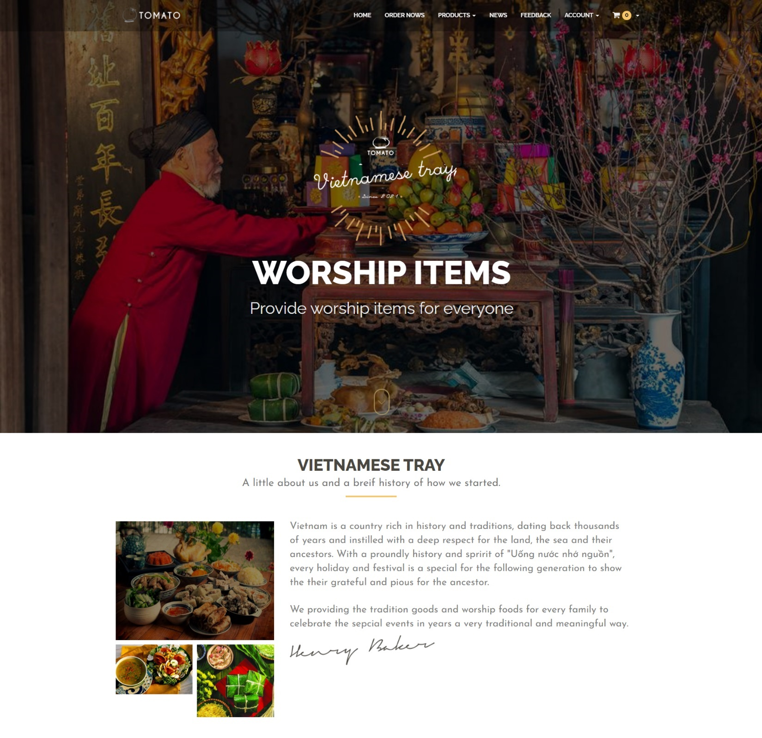

### **- REGISTER**

### **- LOGIN**

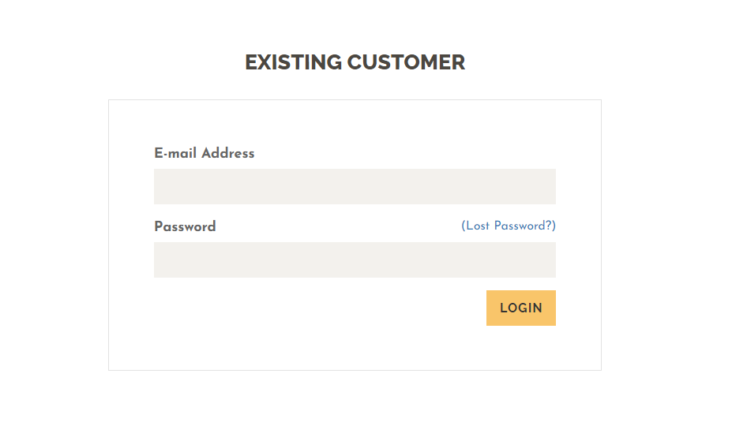

### **- PRODUCT VIEWs**

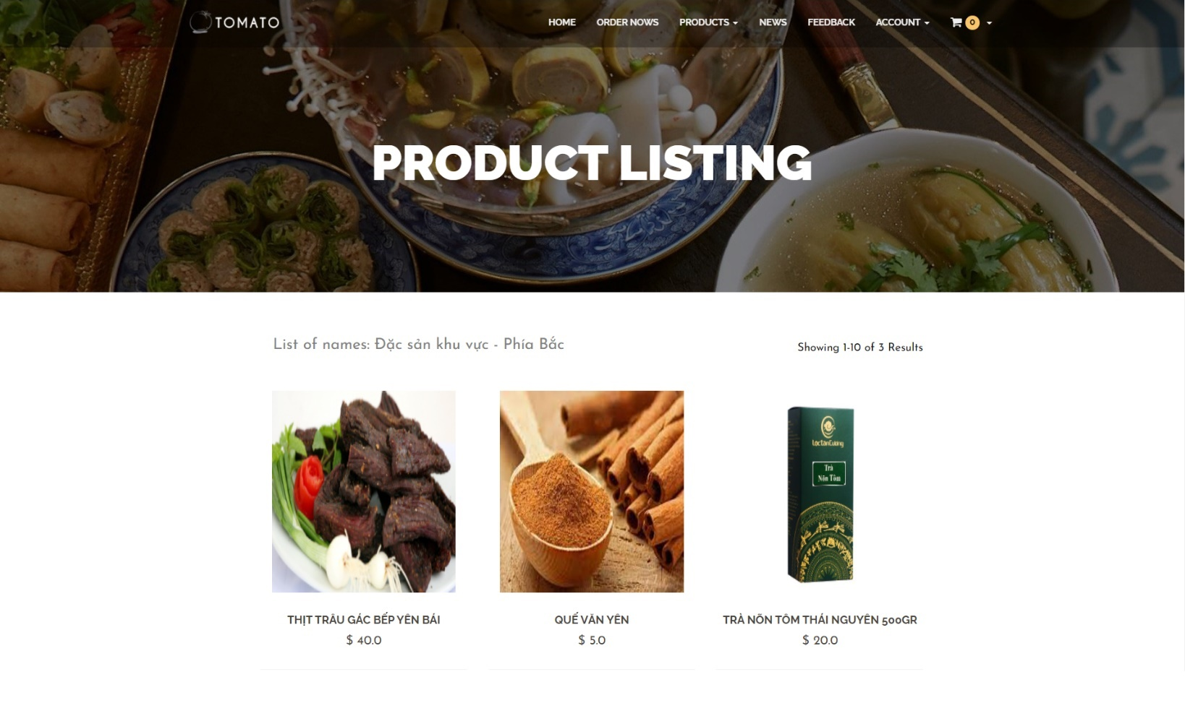

### **- CART DETAIL**

### **- CHECKOUT**

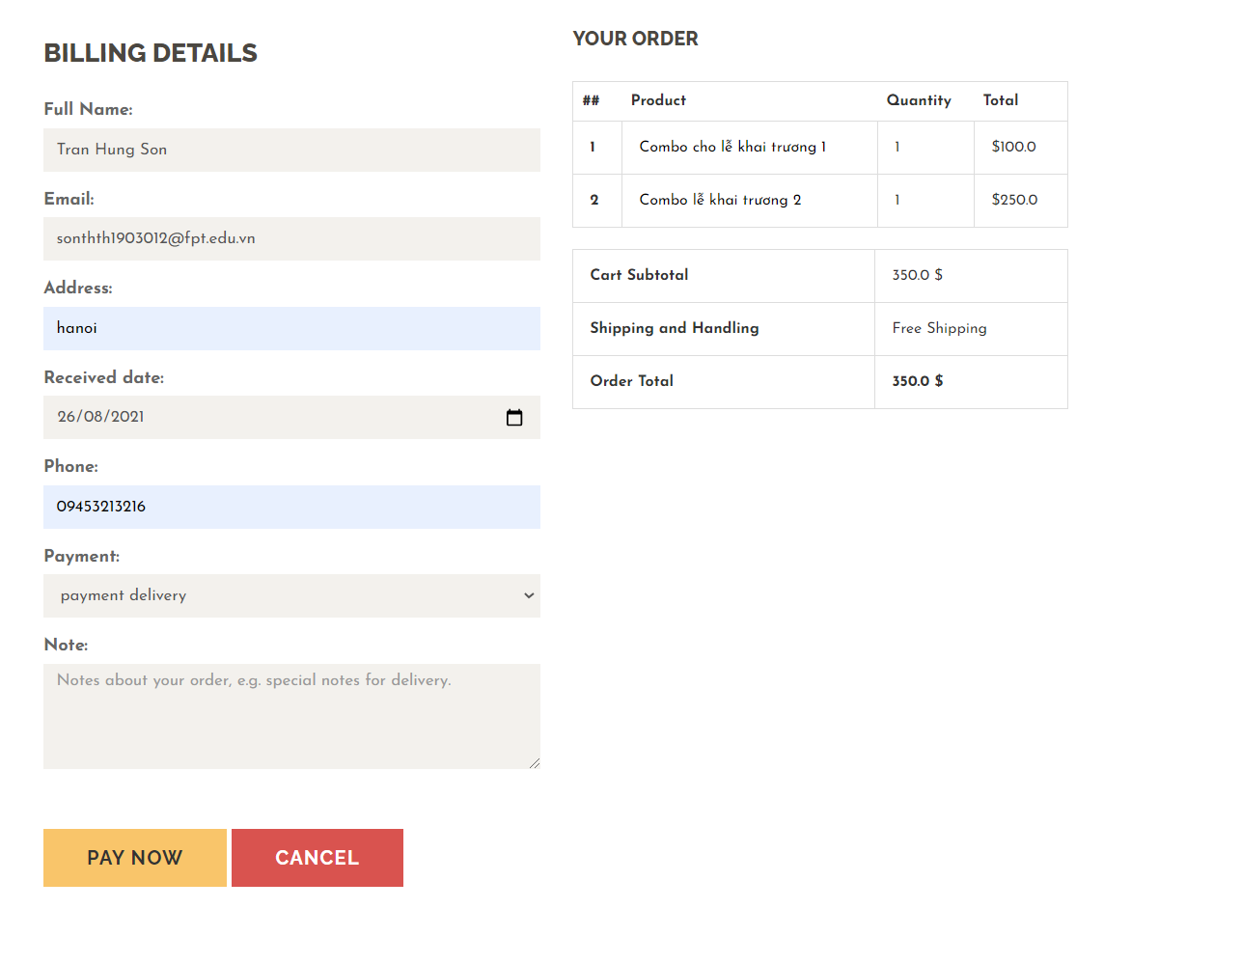

### **- HISTORY**

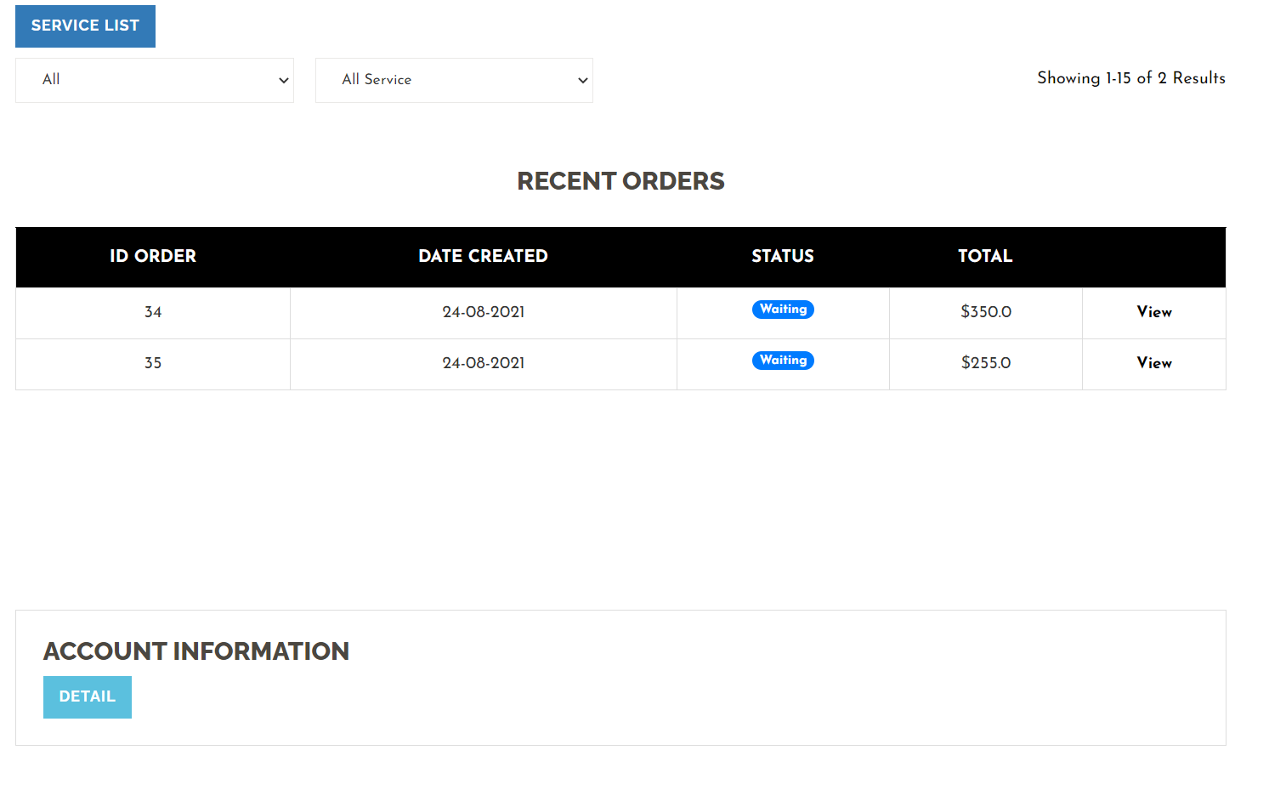

# **Summary**

|  |  |
| --- | --- |
| **WORK TASKS** | |
| **MEMBER** | **TASKs** |
| Phạm Văn Trung (Leader) | -Design Database, finish back-end, debugging. |
| Nguyễn Văn Quyết | -Design UI/UX, Usercase, finish front-end. |
| Trần Hùng Sơn | -Do the testing, write documents. |